**Name: Adithya M SRN: PES1UG20CS621 Section: K**

**Week 10**

1. Screenshot of database with the table - ‘train’ before populating it.

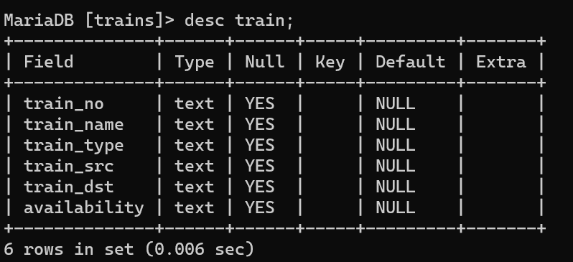

1. Screenshot of the User Interface.

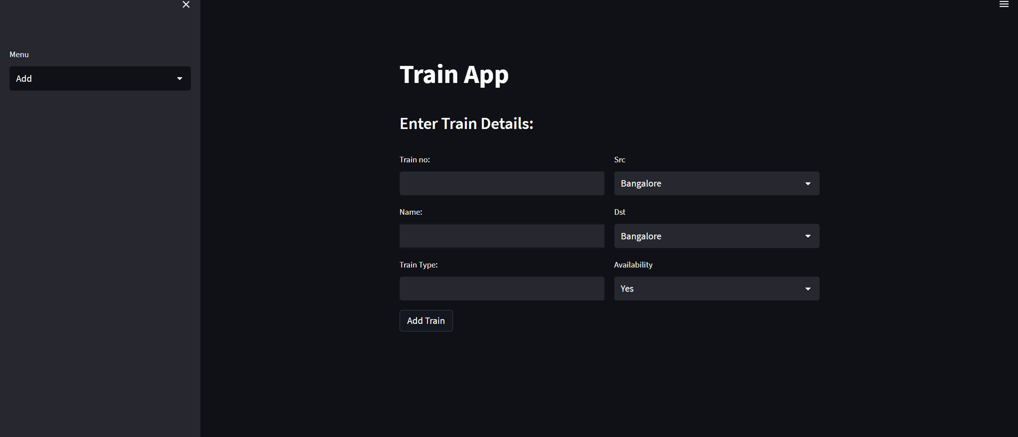

1. Screenshot of the 3 records in the train table from MySQL WorkBench.

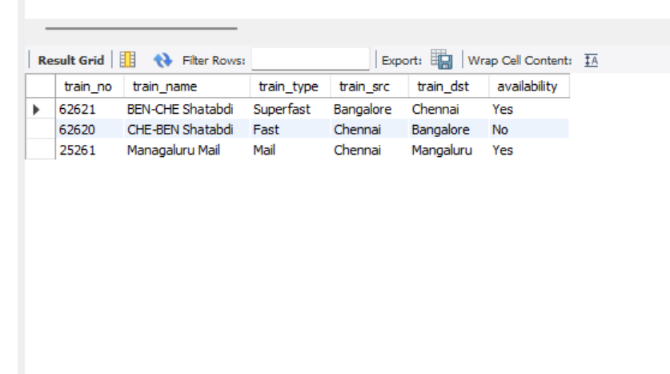

1. Screenshot of the same 3 records visualised in the User Interface.

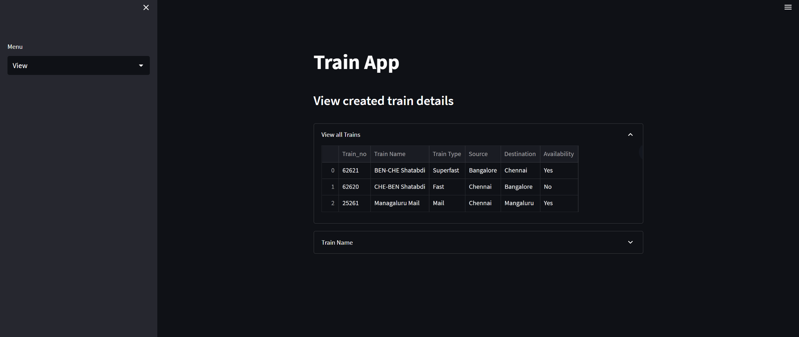

1. Screenshot of Updated Train_No 62620 in the User-Interface.

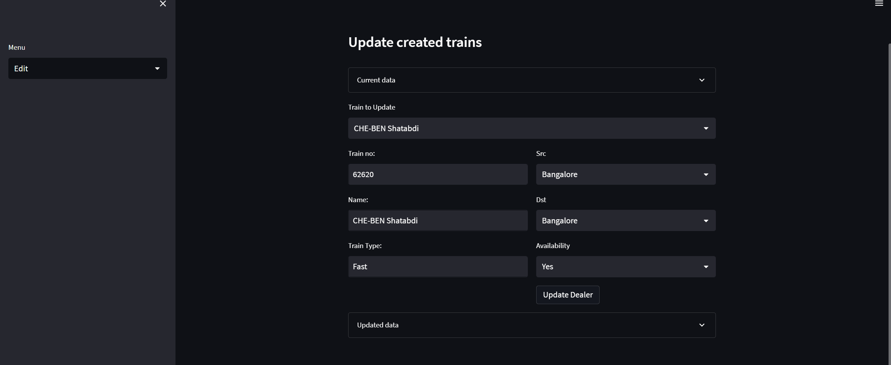

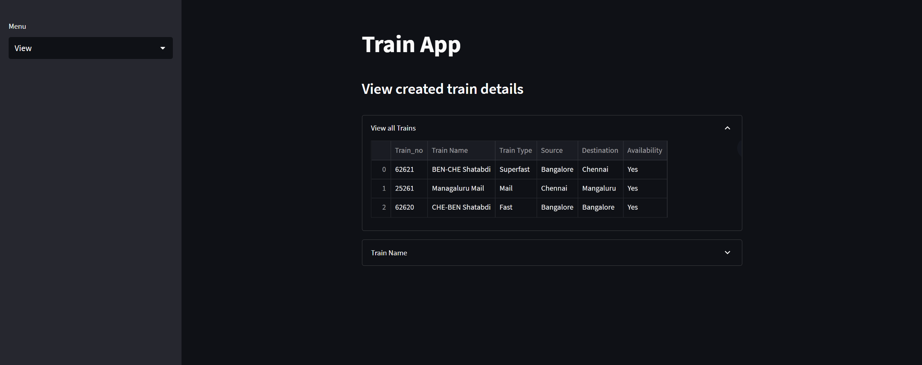

1. Screenshot of User-Interface after the Train_No 25261 has been deleted.

